What is a “version control system”?
Version control systems are a category of software tools that helps in recording changes made to files by keeping a track of modifications done in the code.
Why Version Control system is so Important?
As we know that a software product is developed in collaboration by a group of developers they might be located at different locations and each one of them contributes to some specific kind of functionality/features. So in order to contribute to the product, they made modifications to the source code(either by adding or removing). A version control system is a kind of software that helps the developer team to efficiently communicate and manage(track) all the changes that have been made to the source code along with the information like who made and what changes have been made. A separate branch is created for every contributor who made the changes and the changes aren’t merged into the original source code unless all are analyzed as soon as the changes are green signaled they merged to the main source code. It not only keeps source code organized but also improves productivity by making the development process smooth.
Basically Version control system keeps track on changes made on a particular software and take a snapshot of every modification. Let’s suppose if a team of developer add some new functionalities in an application and the updated version is not working properly so as the version control system keeps track of our work so with the help of version control system we can omit the new changes and continue with the previous version.
Benefits of the version control system:
- Enhances the project development speed by providing efficient collaboration,
- Leverages the productivity, expedites product delivery, and skills of the employees through better communication and assistance,
- Reduce possibilities of errors and conflicts meanwhile project development through traceability to every small change,
- Employees or contributors of the project can contribute from anywhere irrespective of the different geographical locations through this VCS,
- For each different contributor to the project, a different working copy is maintained and not merged to the main file unless the working copy is validated. The most popular example is Git, Helix core, Microsoft TFS,
- Helps in recovery in case of any disaster or contingent situation,
- Informs us about Who, What, When, Why changes have been made.
Use of Version Control System:
- A repository: It can be thought of as a database of changes. It contains all the edits and historical versions (snapshots) of the project.
- Copy of Work (sometimes called as checkout): It is the personal copy of all the files in a project. You can edit to this copy, without affecting the work of others and you can finally commit your changes to a repository when you are done making your changes.
- Working in a group: Consider yourself working in a company where you are asked to work on some live project. You can’t change the main code as it is in production, and any change may cause inconvenience to the user, also you are working in a team so you need to collaborate with your team to and adapt their changes. Version control helps you with the, merging different requests to main repository without making any undesirable changes. You may test the functionalities without putting it live, and you don’t need to download and set up each time, just pull the changes and do the changes, test it and merge it back. It may be visualized as.
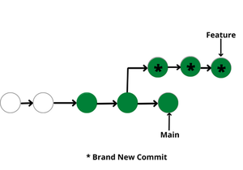

Types of Version Control Systems:
- Local Version Control Systems
- Centralized Version Control Systems
- Distributed Version Control Systems
Local Version Control Systems: It is one of the simplest forms and has a database that kept all the changes to files under revision control. RCS is one of the most common VCS tools. It keeps patch sets (differences between files) in a special format on disk. By adding up all the patches it can then re-create what any file looked like at any point in time.
Centralized Version Control Systems: Centralized version control systems contain just one repository globally and every user need to commit for reflecting one’s changes in the repository. It is possible for others to see your changes by updating.
Two things are required to make your changes visible to others which are:
- You commit
- They update
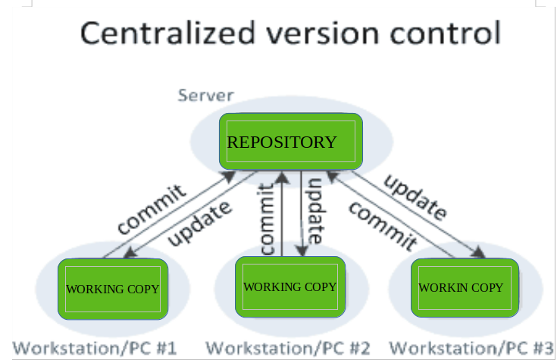
The benefit of CVCS (Centralized Version Control Systems) makes collaboration amongst developers along with providing an insight to a certain extent on what everyone else is doing on the project. It allows administrators to fine-grained control over who can do what.
It has some downsides as well which led to the development of DVS. The most obvious is the single point of failure that the centralized repository represents if it goes down during that period collaboration and saving versioned changes is not possible. What if the hard disk of the central database becomes corrupted, and proper backups haven’t been kept? You lose absolutely everything.
Distributed Version Control Systems: Distributed version control systems contain multiple repositories. Each user has their own repository and working copy. Just committing your changes will not give others access to your changes. This is because commit will reflect those changes in your local repository and you need to push them in order to make them visible on the central repository. Similarly, When you update, you do not get others’ changes unless you have first pulled those changes into your repository.
To make your changes visible to others, 4 things are required:
- You commit
- You push
- They pull
- They update
The most popular distributed version control systems are Git, and Mercurial. They help us overcome the problem of single point of failure.
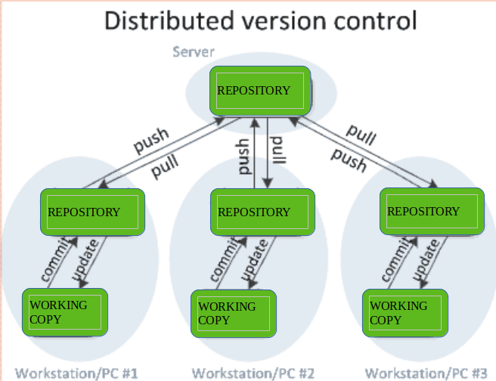
Purpose of Version Control:
- Multiple people can work simultaneously on a single project. Everyone works on and edits their own copy of the files and it is up to them when they wish to share the changes made by them with the rest of the team.
- It also enables one person to use multiple computers to work on a project, so it is valuable even if you are working by yourself.
- It integrates the work that is done simultaneously by different members of the team. In some rare cases, when conflicting edits are made by two people to the same line of a file, then human assistance is requested by the version control system in deciding what should be done.
- Version control provides access to the historical versions of a project. This is insurance against computer crashes or data loss. If any mistake is made, you can easily roll back to a previous version. It is also possible to undo specific edits that too without losing the work done in the meanwhile. It can be easily known when, why, and by whom any part of a file was edited.

What is a VCS? Overview of Version Control Software
VERSION CONTROL
What is version control software? At a basic level, version control is the process of tracking and managing changes to files over time, and version control software helps automate this process. But that is only the beginning of what it does and why it’s important.
Version control software is essential for development teams across all industries. It not only enables them to manage changes to code and files over time, but also allows them to work on the same project simultaneously. A good version control system allows for better collaboration and faster development, and it gives you a complete history of your digital assets.
Read on to learn:

Table of Contents
- What is Version Control?
- What is a VCS (Version Control System)?
- What Are Some Key Version Control Software Benefits?
- How Does Version Control Software Work?
- Types of Version Control Systems
- Version Control Software: Examples of Different Systems
- What Is Git Source Control?
- What is Helix Core Version Control?
Back to top

What is Version Control?
As a process, version control refers to tracking and managing changes to digital assets over time.
There are many ways to implement version control, including simply adhering to a file naming and organizational process. However, the discussion of version control typically refers to version control software/version control systems. These are tools that are designed to help teams work in parallel and prevent loss of important work.
(Note: “version control” is often used interchangeably with the term “source control,” which is specific to tracking source code.)
Let’s dive into what a version control system is and does, and why it’s important.
Back to top

What is a VCS (Version Control System)?
A version control system (VCS) or version control software automates the process of version control. It tracks changes to a file or set of files over time so that you do not have to manage file versions manually or with custom automation scripts. A version control system keeps a complete history of your code and other files, allowing you to return to a previous version if needed.

Branching and Merging in Version Control Software
Branching is a key functionality in version control systems. The diagram below shows a set of historical changes to assets along a diverging hierarchy. The centerline shows the history of a trunk line of assets. Each divergence is considered to be a branch of the trunk line, which is also referred to as the “mainline.”
A typical version control system will call these divergences “branches.” Branches help protect the mainline from unintended problems created by changes in the branch. This isolation is important to the integrity of the overall project. As change progresses over time in each branch (and in the mainline), the divergence, or differences, between the branch and the mainline become greater and greater. To capture the important work in a branch, the changes in the branch must be merged back to the origin branch they came from (usually, the mainline). This is generally referred to a “merge.”
When merges happen, there can be conflicts between the merged branches. These conflicts must be (or should be) resolved to allow the project to progress without error. Doing so preserves the good working assets in the mainline and prevents problems from being carried forward. A good version control philosophy maintains that a “good” mainline be maintained. Doing this is necessary to ensure that branches can be created from the mainline to build on previous work or fix errant behavior that was inadvertently created (also known as “bug fixes”).
📘 Related Reading: Branching Best Practices
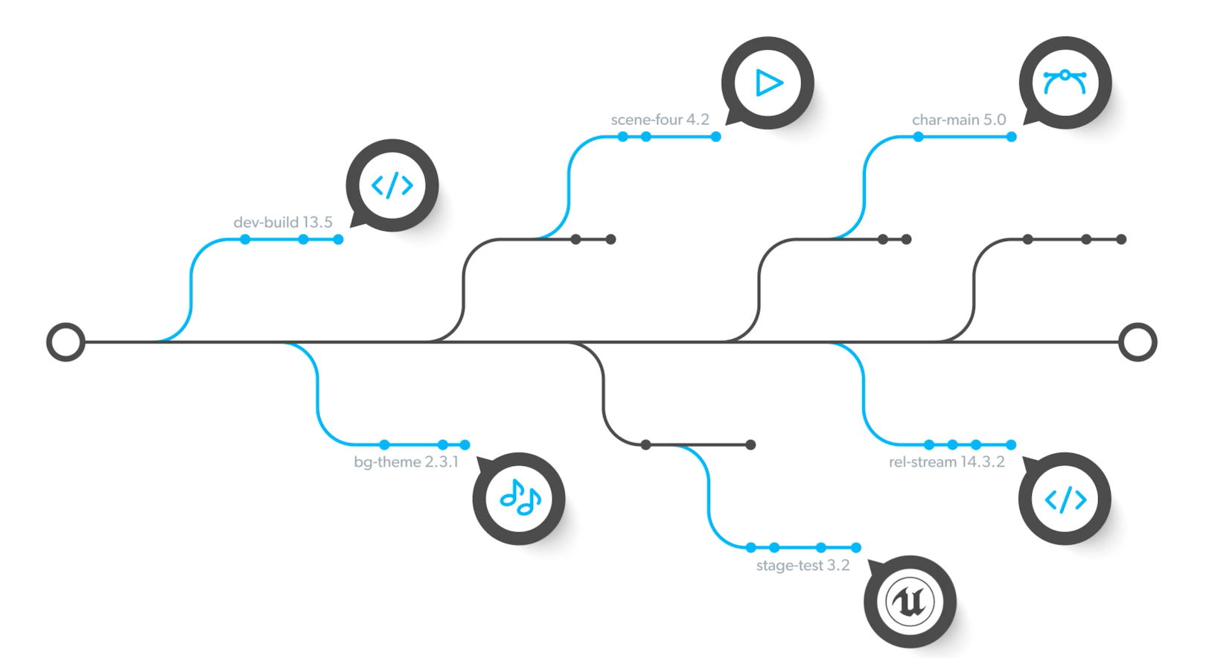

Why Is Version Control Software Important?
Version control is important for keeping track of changes to code, files, and other digital assets. You should use version control software for all assets and development projects that multiple team members will collaborate on.
Version control software needs to do more than just manage and track files, though. It should help you develop and ship products faster. This is especially important for DevOps workflows where delivery of the latest versions can be tested or built during submission of the change. Good version control systems will flag potential conflicts before they enter the mainline of the project. This means the developer can fix the problem and not promote the problem further downstream.
Using the right version control software:
- Improves visibility.
- Minimizes file conflicts and wasted effort.
- Helps teams collaborate around the world.
- Accelerates product delivery.
Back to top

What Are Some Key Version Control Software Benefits?
Using a version control system to manage complex projects has several benefits, from better collaboration to accelerated development. Every version control system is different, but below are some general version control benefits.

Version Control Gives Your Team a Single Source of Truth
One of the primary benefits of using a version control system is that it gives your entire team a single source of truth. This means your whole team is working with the same set of data (files, code, etc.) and can access it in a common location.

Version Control Maintains a Full File History & Improves Visibility
A good version control system allows you to see every change made to every file, who made the changes, and when. A version control system that keeps a full audit history is especially important if you have governance, risk, and compliance (GRC) or regulatory needs. Audit log history is especially key in the automotive, aerospace, medical device, and semiconductor industries.
Furthermore, version control software increases visibility. It allows you to see who is currently working on a file, which helps teams avoid duplicated effort or overwritten files. It also allows you to easily revert to a previous version of a file if you run into an issue.

Version Control Enables Concurrent Development
As your development projects get more complex, you will face a growing need to manage multiple versions of code and files — and entire products. You will likely have many team members contributing to the same project at one time.
A good version control system enables concurrent and parallel development. In an essence, this means multiple developers and designers can work on the same set of files without worrying that they are duplicating effort or overwriting other team members’ work. It also means you can develop and get products to market faster.
Let’s say you're managing an IoT deployment for high-end internet-connected security cameras. Over the product lifecycle, you may use ten different types of cameras, each with a different chip. As a result, each will have different software.
Using the right version control software means you can maintain multiple versions of your code to manage the specific functionality of each camera's chip and operating system. In our example diagram, this might mean that each different camera is developed on its own code line branch, and any common elements or good work could then be merged back to the mainline to be used later. This idea of code reuse is very important in a good version control system.
So, when you need to deploy a critical security patch to prevent hackers from hijacking those cameras, it is easy. You will instantly see which code is impacted, make the changes, and deploy a fix.

Version Control Enables Better Team Collaboration
Having visibility into who is working on what and the ability to work on the same project at the same time makes for better collaboration. For large, complicated development projects with multiple contributors, version control is a necessity for efficient collaboration.
Additionally, companies operate where the talent lives. You may need a way to provide global access to your team members at all your facilities. Having a single source of truth –– with appropriately secured identity and access management –– is critical for your success. With the right version control system, each team member can easily access and work on the latest version of a project.

Version Control Supports Automation Within Development
Higher quality and increased productivity are top priorities for today’s development teams. And your team can reach your goals by automating tasks, such as testing and deployment.
In software development, Continuous Integration (CI) with automated builds and code reviews are a standard operating procedure.
For hardware development, such as semiconductors, automation can include:
- Testing with field programmable gate arrays (FPGAs).
- Integration with simulation verification and synthesis systems.
Such FPGAs or verification and testing systems must themselves be controlled and versioned, along with potentially very large data files. It is vital that even small changes are tracked and managed. This means your version control software is the center of the IP universe. The right one can handle millions of automated transactions per day with millions of files.
Back to top

How Does Version Control Software Work?
Version control software automates the process of version control. It automatically keeps track of changes made to a file or set of files over time.
Here is a simplified explanation of how most version control software works:
- A repository is created, where files and all their versions will be stored over time.
- As changes are made to files that are stored in the repository, they are automatically tracked so you can see what was changed, when, and by whom.
- If one team member wants to work on a file, they can check out the file, make changes, and then commit those changes/check them into the repository once they are done. Checking out the file in this way ensures others on the team know that it is being worked on, which prevents them from overwriting the other’s changes. Once changes are checked back in, the new latest file version becomes available to the rest of the team. Good version control software will allow a team member to “lock” a file to prevent changes from happening beneath their work. This is especially important when working with large binary assets that cannot be easily merged.
- If a team member wants to make changes to a project without impacting other users — for example, if they want to experiment with a new feature — they can create a new branch. This is essentially a copy of the project. They can work in isolation on their changes in their own branch, then merge it back into the main branch.
Watch the video below to learn more about how version control works.

Back to top

Types of Version Control Systems
What types of version control systems are available for your business?
The two most common types of version control systems are centralized and distributed. Centralized version control stores all changes in one central location. With distributed version control, each team member makes changes to a local copy of the repository on their computer.

Centralized Version Control
In a centralized version control system (CVCS), one single server stores all of the versions and changes to all files. With this type of version control, users can check out a file to work on it and make changes before checking it back into the central server. Or they can create a separate branch of the project, work on it alone, and merge it back into the main branch. All changes — all commits and merges — are synced to the central server.
One of the main benefits of a centralized VCS is that every user has quick access to the latest version of a file. This greatly reduces the possibility of overwriting each other’s work, duplicating effort, or wasting effort by making changes to files that cannot be merged (like binary files).

Distributed Version Control
With a distributed version control system (DVCS), each user downloads a copy of the repository so they can make changes to files locally (on their own machine). There is a main repository, but rather than storing every file and all of its changes, this main repository just saves the differences between files (except in the case of binary files).
One advantage of this type of version control is that it can be quicker for users to commit changes than some centralized version control systems. It is also allows users to work offline.
Back to top

Version Control Software: Examples of Different Systems
There are many version control systems on the market. Some are free, some are proprietary, and all have their own advantages and disadvantages. Here is a summary of some of the most popular version control tools available:
- Helix Core — Helix Core is a centralized version control system by Perforce Software. It’s the leading version control system for game developers and is also used in media & entertainment and semiconductor design, among other industries. It offers visibility to collaborative teams, showing when others are using the same data, and it provides a locking strategy to prevent the overwriting of critical data. It is free for up to five users.
- Git — Git is a widely popular, distributed control system for developers. Git source control is open-source and therefor free to use. It offers easy branching and is great for small projects but has file and repo size limits.
- SVN — SVN (short for Subversion) is another free, open-source version control system developed by Apache. It is a centralized version control system. It offers good concurrent development processes, but its branch and merge functions are not strong.
- ClearCase — IBM Rational ClearCase, or simply ClearCase, is a software configuration management tool used for version control. It is a centralized system. It is not free to use.
- Mercurial — Mercurial is a free, distributed version control system that launched in 2005. It is considered simpler and easier for beginners to use than more complex systems, like Git.
- Plastic SCM/Unity Version Control — This version control tool was developed by Codice Software and is now owned by Unity. It is a distributed version control system. It is not free to use.
- TFS — Microsoft TFS (Team Foundation Server), now rebranded as Azure DevOps Server, is a tool for version control, issue tracking & reporting, and application lifecycle management.
Learn more about the differences between the top version control systems. Check out this chart to see key strengths and weaknesses of the most popular tools.
Compare version control systems >>
Back to top

What Is Git Source Control?
Git source control is open source, meaning anyone can use it. It's a distributed, free version control software, and it is one of the most popular options.
But there are some drawbacks to using Git source control. Git lacks security. It's impossible to scale. It was not designed for artists, designers, and other teams who need to version large binary and art files. It also makes it very difficult to get a single source of truth. That's why teams who choose Git source control often add other tools on top of it to better suit their needs.
Back to top

What is Helix Core Version Control?
As explained above, Helix Core is a centralized version control system developed by Perforce Software, a leading provider of DevOps solutions. Here is a rundown of what sets Helix Core apart from other types of version control systems, including Git source control:
- It serves as a single source of truth for your entire team, from developers to artists.
- It is lightning-fast, even for remote and globally dispersed teams. It can handle 10,000+ concurrent commits without slowing down.
- It offers enterprise-grade security and granular access control, down to an individual file and IP address.
- It offers advanced branching capabilities with its built-in tool, Perforce Streams.
- It scales endlessly without sacrificing performance.

